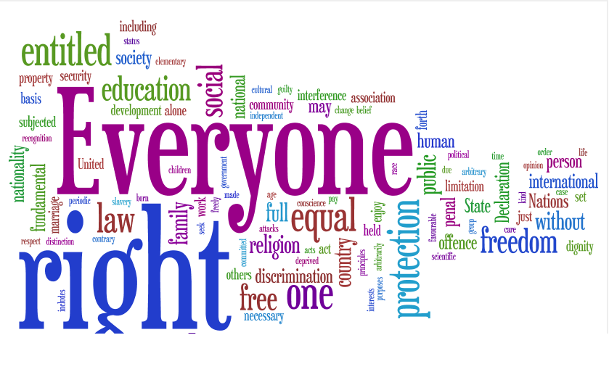
2024-26
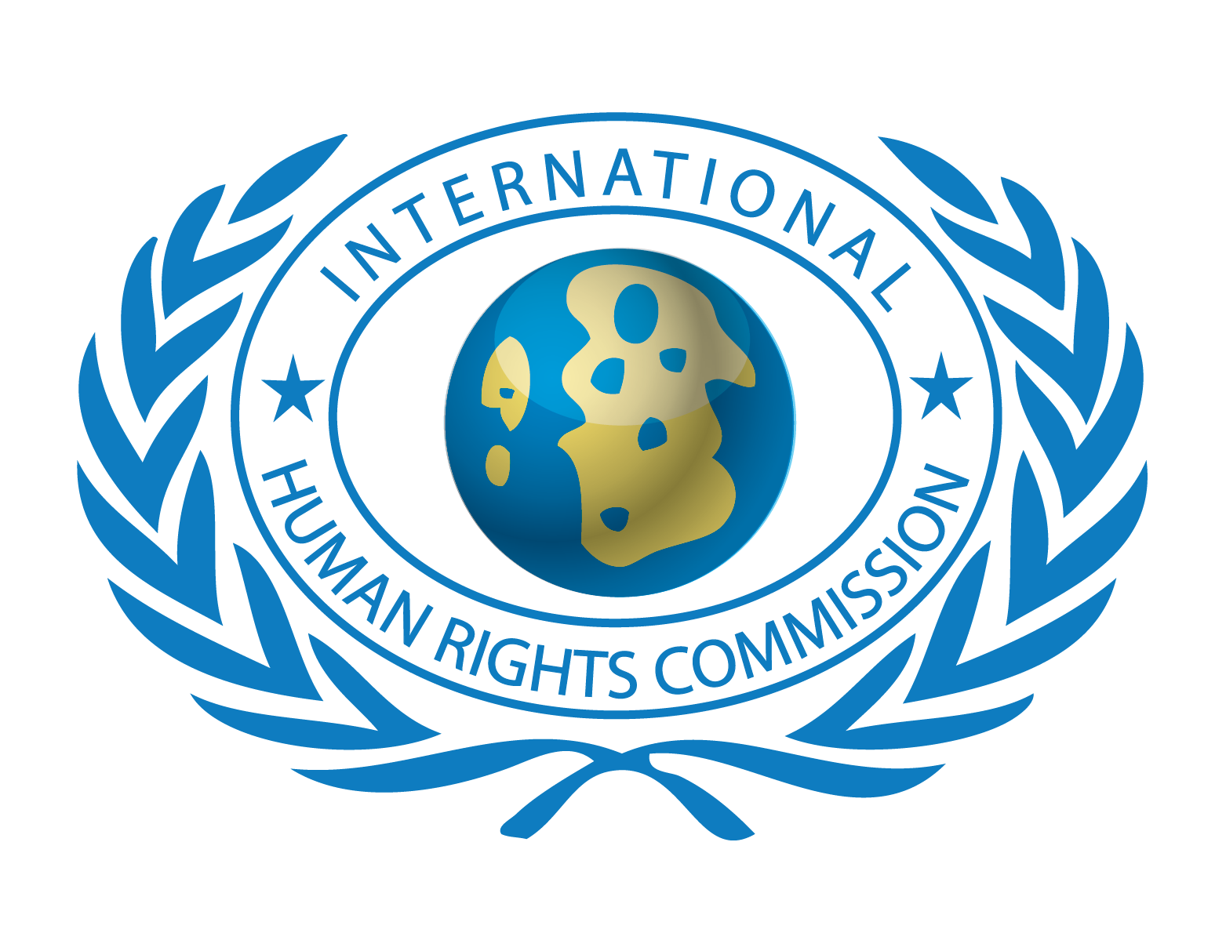
IHRC GLOBAL MEMBERSHIP
VOLUNTEERS CROPS

COMPLIED BY DEPARTMENT OF PUBLIC INFORMATION P A G E | 1
INTERNATIONAL HUMAN RIGHTS COMMISSION
https://www.ihrcrft.org
GLOBAL MEMBERSHIP APPLICATION FORM
Paste Photograph here
Size: 2x2 Inches

- PERSONAL INFORMATION

Full Name
Father’s Name
Age + Date of birth
Gender + Marital Status
I.D Card / Passport /Nationality
Institution/ Profession
Institution Address
Home Address
Phone # (Institution)
Phone # (Home)
Fax # (if available)
Mobile #
Website
Email address

- EDUCATIONAL BACKGROUND & LANGUAGES

- For each degree please specify the following data:

Type of degree | Field of study | Grade obtained | Dates (month/year) | Distinction

- Complete the following table for all languages known other than the mother tongue, using only the Number corresponding to the level attained.

5= fluent, high level of accuracy, near mother-tongue competency;
4= very good, ease of usage, few errors;
3= good, some difficulty, fair number of errors;
2= some knowledge, difficulties, many errors;
1= very basic knowledge
Language | Speaking | Writing | Reading | Listening
English
French
Italian
Spanish
Arabic
Hindi
Urdu
Russian
German
Persian
Other ___________

- GUIDELINES

Send, no later than 2 completed copies of each of the following, in the same envelope:
- Completed and signed application form
- Curriculum Vitae, Formal Picture along with copy of National Identity Card

I hereby certify that all the personal data provided in this application are true and correct.
The above requested data are collected for purposes relating to the selection of International Human Rights Commission membership ONLY.

I apply for membership of the International Human Rights Commission and agree to abide by its Constitution and rules.

Digital/Signature of Applicant

HEADQUARTER & SECRETARIAT ‘S
PAKISTAN: 148 Main Road, G-7/2-4,Islamabad 44000, Pakistan, Tele: 92-332-8555711(whatsapp only) E-mail: ihrcigo@gmail.com
USA: NEW YORK-SECT: 50 Clinton Street, Suite 99, Hempstead, New York 11550, Tele: +1-516-743-9000 USA Email: info@ihrc-hq.org
SWITZERLAND: GENEVA; 31 Rue Vollande, 1207 Geneva, Switzerland, Tele: +41-77-238-3561, Fax: +41-77-966-4839

THE RULES FOR GLOBAL MEMBERSHIP OF IHRC
WHAT WE DO
- The International Human Rights Commission is dedicated to protecting the human rights of people around the world and promoting the cultural of Peace among the nations.
- We stand with victims and activists to prevent discrimination, to uphold political freedom, to protect people from inhumane conduct in wartime, and to bring offenders to justice.
- We investigate and expose human rights violations and hold abusers accountable.
- We challenge governments and those who hold power to end abusive practices and respect international human rights law.
- We enlist the public and the international community to support the cause of human rights for all.

A. Eligibility for Global Membership.
Any person having the following qualification shall be eligible for Global membership of the Commission: -
(1) Who is of or above 18 years age?
(2) Who has reputable character and sound mind?
(3) Who agrees to abide by the constitution and bylaws of the Commission and supports the aims & objects of the IHRC?
(4) Who agrees to pay the prescribed fee of the Commission?
(5) No employee of the commission can become member of the IHRC.
B. Fee
A person whose application for membership is approved by the World Chair or Secretariats shall become Global Member of the Commission on payment of an annual membership fee of US$ 300 for developed countries, US$ 200 for developing and US$ 100 under developing countries along with DHL Charges US$ 50 for oversees countries of IHRC Secretariats.
C. Rights and privileges of Members.
Global members shall have the right to take part in the meetings and functions of the Commission and hold office in it: -
D. WHAT BENEFITS TO GET?
- Opportunity to learn-earn-serve by getting involves & participates in international volunteer projects through IHRC service and learning programs conducting in various parts of the world;
- Opportunity to work as volunteers with IHRC Partners/ Business Organizations / Corporate Institutions working as their representative in your country and abroad;

- Opportunity to get Invitation to attend international events, Conferences, workshops training sessions, exhibitions etc. Free of Cost if organized by IHRC or any partner organization, state or government organization on Cost with special discounts in consultancy & registration;
- Special assistance and guidance provided in applying for study abroad or internship programs globally;
- Special discount on the reservation in hotels, motels, and hostels under the IHRC partner organization worldwide;
- Free job placement information services and consultancy service by the IHRC JOB BANK;
- Guidance on getting international grants/Funds & scholarships globally;
- Issuance of international identification card of IHRC to all Global members & issuance of International Membership Certificate on the payment of postage cost other than the membership fee.

IHRC GUIDELINES FOR GLOBAL MEMBERS

HOW TO GET BENEFITS FROM THE IHRC AS A GLOBAL MEMBER?
- All Global Members should submit their quarterly reports in which they explain what activities or efforts they did during the every quarter of the year & how these will be promoting the objectives of IHRC.
- Send monthly updates on how many members, you are been able to introduce during the month.
- Every 10th December Submit your recommended proposals /grants and sponsorship requests (if available) for any project related to Human Rights Awareness, AIDS, Education, Shelter, Peace, Environment & Climate Change, Informative Seminars, and Relief for the approval & support.
- Send Articles, Reports and news updates on the IHRC goals related subjects to unite the efforts to secure within the international community a high level of cooperation and responsibility on issues related to Peace and Social Development; Human Rights, Peace Keeping and Disarmament, Social Development, Education, Climate Change, NGO Networks, Environment, Youth Development, Health, the Empowerment of Women, Media and Democracy, Good Governance and Corruption Free Administration.
- Send your interests on what benefits you would like to avail from the member’s benefits list.

COMPLIED BY IHRC DEPARTMENT OF PUBLIC INFORMATION

